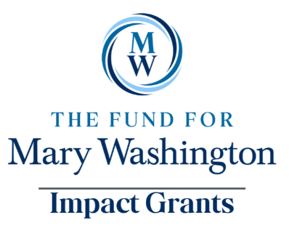
2026-2027 Impact Grants Narrative Report
Please complete the questions below with a short paragraph each, and please be as specific as possible. Please submit this completed report, along with your financial report via email to Beth Hunsinger no later than June 30, 2027: ehunsing@umw.edu
- How did the Impact Grant advance the work of your organization/campus unit, and how did it contribute to the UMW community as a whole?

- Did you accomplish the goals outlined in your grant proposal? Why or why not? If you had to change gears for any reason or encountered extenuating circumstances, please explain those here.
- What did you learn from the grant process, from application through implementation of the project or initiative outlined in your proposal? If there is anything you would have done differently, explain what and why.
- If you were asked to write a thank-you letter to the donors who funded your grant, what would you write? Please include specific examples of the donors’ impact.
- (To be completed only by those who did not spend all grant funding) Explain why you did not spend all of the grant funds awarded.

